10/30/2023

**ICS 2240;**

**INTRODUCTION TO COMPUTER AND DATA**

**GROUP MEMBERS;**

MBUGUA SUSAN WANGARI - HSB214-OO83/2022

MARY WANGUI MUNENE - HSB214-0102/2022

CHRISTABEL AMODING – HSB214-0076/2O22

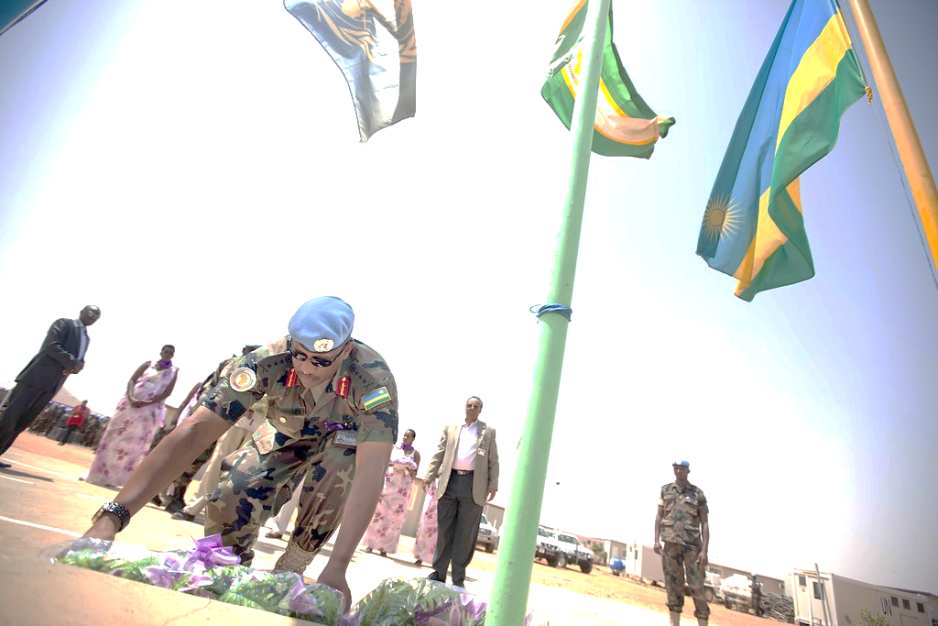 **GENOCIDE IN RWANDA**

The genocide in Rwanda, which occurred in 1994, was a tragic and horrific event in which an estimated 800000 people, primarily of the tutsi ethnic group, were brutally killed over a period of 100 days. The genocide was driven by long standing tensions and political conflicts.

Factors that contributed to the genocide

* Historical division between the Hutu and Tutsi ethnic groups
* Political manipulation and propaganda that fuelled hatred and violence
* The assassination of Rwandan president in April 1994

The international community including the UN faced criticism for not taking effective action to prevent the genocide despite being aware of the situation .it was stark reminder of the challenges of international intervention in such crises

In the aftermath, Rwanda faces the immense challenge of rebuilding a shattered society and reconciling the divided ethnic groups .the country has made significant progress in the years since but the scars of the genocide still linger.

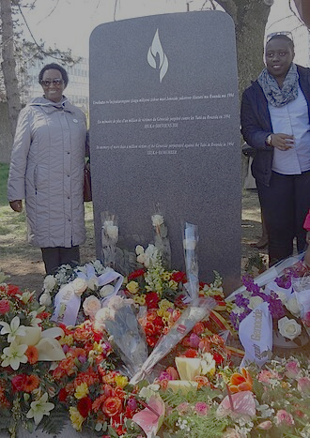**Effects of the genocide in Rwanda**

1. **Loss of life-the genocide resulted in the deaths of an estimated 800000**
2. **Trauma and psychological impact**
3. **Social disruption**
4. **Economic impact**
5. **Humanitarian crisis**
6. **International response**
7. **Reconciliation and rebuilding**
8. **Political changes**
9. **International awareness**
10. **Prevention and peacekeeping**

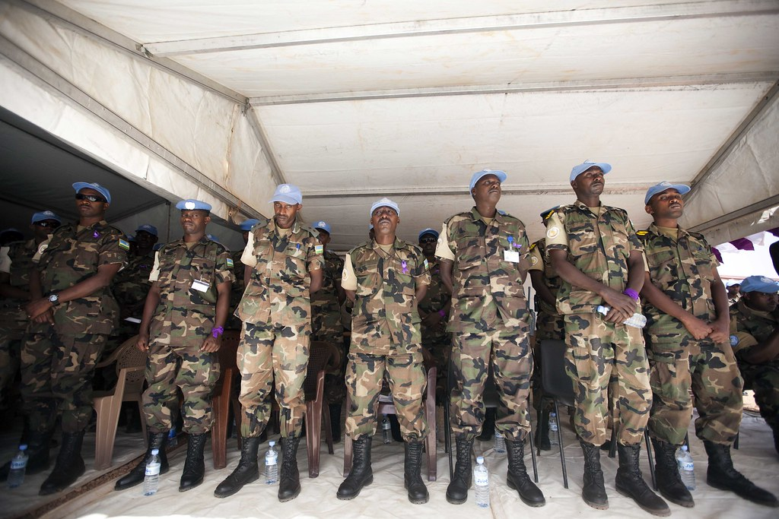

The genocide in Rwanda left a lasting impact on the country and served as a sobering reminder of the consequences of ethnic hatred and the importance of international action in preventing such atrocities.

|  |  |  |
| --- | --- | --- |
| Prefecture  [region] | Hutu | Tutsi |
| Butare | 618171 | 135696 |
| Byumba | 761968 | 13966 |
| Cyangugu | 489238 | 62326 |
| Isenyi | 708562 | 23423 |
| gitarama | 764920 | 83106 |
| Kibungo | 596999 | 51912 |
| Kibuye | 398130 | 71363 |
| Rural kigali | 822313 | 83318 |
| City kigali | 180550 | 41255 |
| ruhengeri | 759127 | 7667 |
| Totals | 7,099,844 | |